|  |  |
| --- | --- |
| **Full Name :-** | Dilip Sharma |
| **Student ID :-** | Sharma.dilip137@gmail.com |
| **Batch :-** | Full Stack Java Developer |
| **Project Title :-** | LockedMe.com |
| **Project Submission Date :-** | 30th Jan 22 |

**Project Source Code:-**

**package** LockedMe.com;

**import** java.io.File;

**import** java.io.FileWriter;

**import** java.util.LinkedList;

**import** java.util.Scanner;

**public** **class** LockedMe {

**static** **final** String ***projectFilePath***="E:\\fio";

**static** **final** String ***errorMessage***="Some error is occurred in the program please contact to sharma.dilip137@gmail.com";

**static** Scanner *sc*=**new** Scanner(System.***in***);

// This Methods will display the Menu items.

**public** **static** **void** displayMenu()

{

System.***out***.println("********************************************");

System.***out***.println("\nWelcome to LockedMe.com\n");

System.***out***.println("********************************************");

System.***out***.println("\tDesigned By Dilip Sharma\n");

System.***out***.println("********************************************");

System.***out***.println("1. Display all the Files :- ");

System.***out***.println("2. Add a New file");

System.***out***.println("3. Delete a file");

System.***out***.println("4. Search a file ");

System.***out***.println("5. Exit.\n ");

}

// This method will display all the files.

**public** **static** **void** getAllFiles()

{

**try** {

File file=**new** File(***projectFilePath***);

File[] listoffiles=file.listFiles();

**if**(listoffiles.length==0) {

System.***out***.println("Does not exist the file.");

}**else** {

**for**(**var** l:listoffiles)

{

System.***out***.println(l.getName());

}

}

}**catch**(Exception ex) {

System.***out***.println(***errorMessage***);

}

}

// This method will create a new file.

**public** **static** **void** createFiles()

{

**try** {

String filename;

System.***out***.println("Enter the file name:");

filename=*sc*.nextLine();

**int** linescount;

System.***out***.println("Enter how many lines in the file");

linescount=Integer.*parseInt*(*sc*.nextLine());

FileWriter myWriter=**new** FileWriter(***projectFilePath***+ "\\"+filename);

**for**(**int** i=1;i<=linescount;i++) {

System.***out***.println("Enter the file line:");

myWriter.write(*sc*.nextLine()+"\n");

}

System.***out***.println("File is created successfully.");

myWriter.close();

}

**catch**(Exception ex) {

System.***out***.println(***errorMessage***);

}

}

// This method will delete the file.

**public** **static** **void** deleteFiles()

{

**try** {

String filename;

System.***out***.println("Enter the file name for delete");

filename=*sc*.nextLine();

File file=**new** File(***projectFilePath***+ "\\"+filename);

**if**(file.exists()) {

file.delete();

System.***out***.println("File is deleted successfully.");

}

**else** {

System.***out***.println("File is not deleted.");

}

}

**catch**(Exception ex)

{

System.***out***.println(***errorMessage***);

}

}

// This method will search the file according to user.

**public** **static** **void** searchFiles()

{

**try** {

String filename;

System.***out***.println("Enter file name for search.");

filename=*sc*.nextLine();

File file=**new** File(***projectFilePath***);

File[] listOfFiles=file.listFiles();

LinkedList<String> filenames=**new** LinkedList<String>();

**for**(**var** l:listOfFiles) {

filenames.add(l.getName());

}

**if**(filenames.contains(filename))

System.***out***.println("File is available");

**else**

System.***out***.println("File is not available");

}**catch**(Exception e) {

System.***out***.println(***errorMessage***);

}

}

**public** **static** **void** main(String[] args) {

**int** ch;

**do** {

*displayMenu*();

System.***out***.println("Enter your choice: ");

ch=Integer.*parseInt*(*sc*.nextLine());

**switch**(ch) {

**case** 1: *getAllFiles*();

**break**;

**case** 2: *createFiles*();

**break**;

**case** 3: *deleteFiles*();

**break**;

**case** 4: *searchFiles*();

**break**;

**case** 5: System.*exit*(0);

**break**;

**default**: System.***out***.println("Invalid Option");

**break**;

}

}**while**(ch>0);

*sc*.close();

}

}

**Output: -**

1. **Display all the files: -**

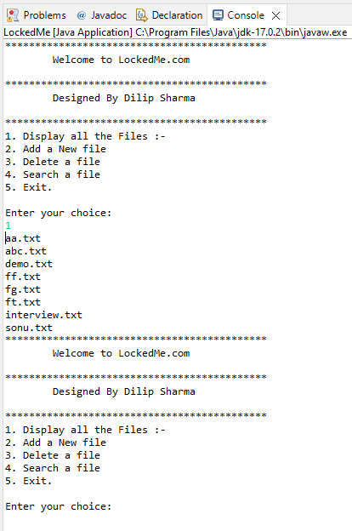

1. **Add a new File: -**

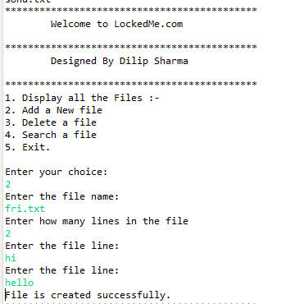

1. **Delete a File: -**

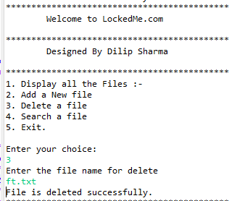

1. **Search a file: -**

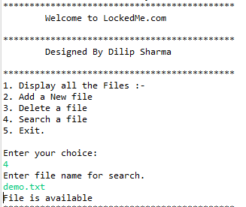

1. **Exit.**

